1. Company Profile
Company Name: AlcoVerse Retail Group
Field of Activity: Multi-channel retail(online and offline) of alcoholic beverages, operating through a network of physical boutiques (Offline POS) and a centralized E-commerce platform (Online Web-store). The company focuses on a wide assortment, ranging from mass-market products to premium exclusive brands.
2. Business Process
Business process presented by multi-channel sales lifecycle & promo optimization. This process covers the end-to-end retail cycle across our web-store and physical stores. It processes transaction-level data to connect sales results (revenue and volume) with marketing efforts based on location. The goal is to analyze how geography, product assortment, and pricing actions interact to drive business growth.
3. Business Questions and Problems to Resolve
1. Channel Performance
Business Problem: Lack of visibility into which sales channel drives higher financial efficiency versus pure transaction volume.
Analytical Questions: What is the revenue share split between the E-commerce platform and physical stores?
- How does the Average Order Value differ across channels?
- Are there specific purchasing patterns on weekends where offline traffic surges compared to online demand?
2. Promotional Campaign & Discount Effectiveness
- Business Problem: Marketing campaigns are frequently launched, but the business cannot reliably measure the true "sales lift" versus margin cannibalization.
- Analytical Questions: Which promotional campaigns generated the highest sales volume expansion in gallons or liters?
  - What is the correlation between the discount depth (discount) and the velocity of bottles sold (bottles_sold)?
  - Are specific vendors or item categories more sensitive to promotional discounts?
3. Assortment Optimization and Vendor Management
Business Problem: Capital is tied up in slow-moving inventory, while high-demand items frequently suffer from out-of-stock scenarios.
Analytical Questions: Who are the top-performing and underperforming vendors (vendor_name) by total revenue and volume sold?
- Does consumer behavior show a preference for premium, higher-priced items (higher price per bottle/volume) in the online store compared to physical locations?
4. Geographical Performance
Business Problem: Suboptimal performance in certain physical store locations without clear geographical context.
Analytical Questions: Which counties and cities are leading in sales performance, and which are lagging?
4. End Users of the Report
Chief Commercial Officer (CCO): Requires high-level strategic overviews to monitor total revenue (sale_dollars), overall target fulfillment, channel performance ratios, and macro growth trends.
Head of Marketing: Focuses on promotion and markdown efficiency metrics (promo_id, discount) to evaluate which campaigns drive true volume growth versus those that dilute product margin.
5. Purpose of the Report
To provide a centralized dashboard (Single Source of Truth) that enables executives and managers to monitor key commercial metrics, compare online vs. offline channel performance, optimize product assortment, and evaluate the true impact of marketing promotions on sales volumes and profit margins.
Data Connection, Load & Data Model
The data was loaded into Power BI Desktop via the built-in PostgreSQL database connector (Get Data → PostgreSQL). The connection was established to a local server (localhost) using the default postgres database. Import mode was selected over DirectQuery, as all source data resides in a pre-built Data Warehouse where tables are already aggregated and optimized — Import mode ensures faster report rendering and full DAX calculation support without live query overhead:
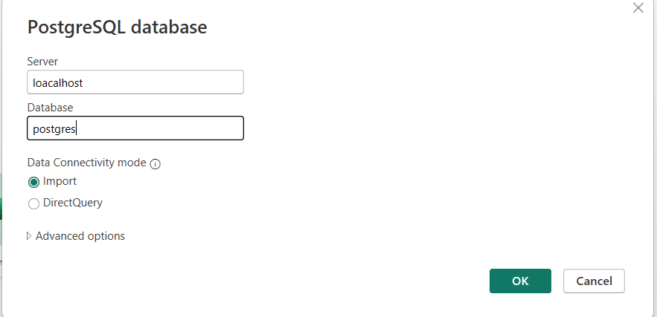From the Navigator, the following six tables were selected and loaded directly into the Power BI model:
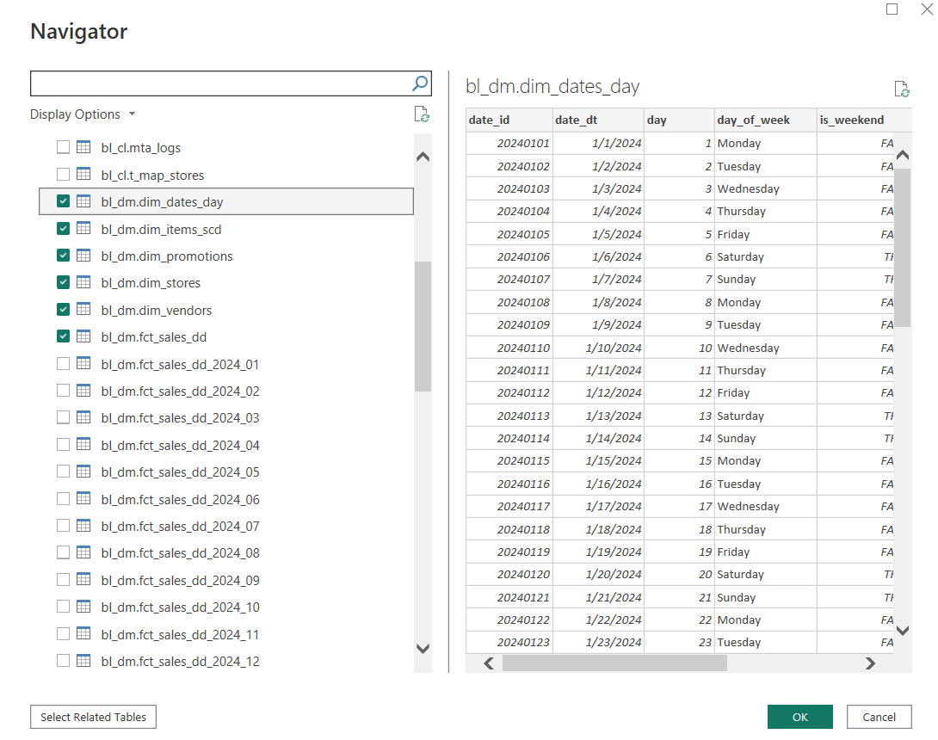
The partitioned monthly tables (fct_sales_dd_2024_01 through _12) were intentionally excluded, as the unified fct_sales_dd table already consolidates the full historical dataset across all periods.
No data transformation or cleaning was performed in Power Query, because all source tables arrived from a pre-built, structured Data Warehouse (DWH) pipeline where cleansing, deduplication, and standardization had already been applied at the ETL layer. This made the Load-only approach fully sufficient.
After loading, relationships were established in the Power BI Model View, resulting in a classic Star Schema structure — one central Fact table surrounded by Dimension tables
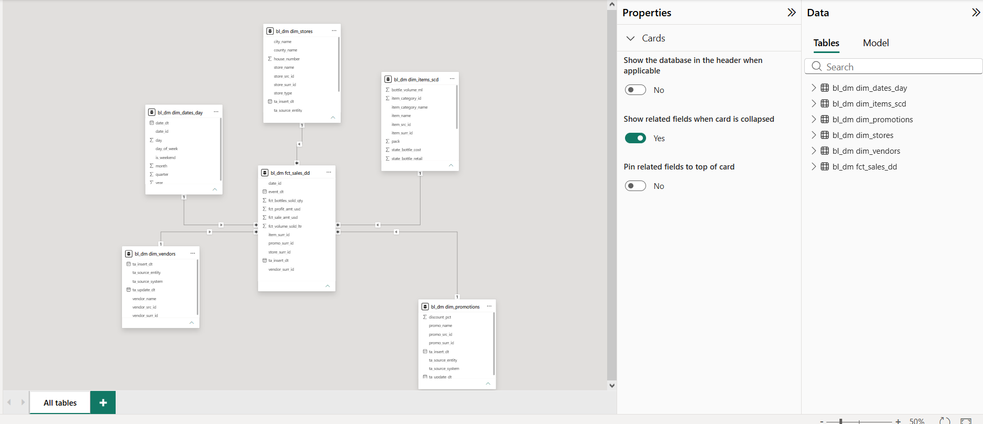
Report Page 1: Sales Performance Overview
The report was designed to provide a user with a high-level operational and financial summary of AlcoVerse Retail Group's multi-channel performance. It acts as a comprehensive analytical environment that connects gross metrics with final profitability, resolving core blind spots in revenue structure, margin leakages, and seasonal trends.
1. Executive KPI Summary Cards
Four headline cards display the most critical financial aggregates across all periods and channels. These cards respond dynamically to the Month and Year slicers, allowing user to isolate any time window instantly. The following DAX measures were created to power them Total Revenue, Total Gross Revenue (Total Revenue before discount deductions), Total Discount , Total Net Profit.
2. Monthly Trend: Actual Revenue vs. Bottles Sold
A combo chart overlaying a bar series (Bottles Quantity) with a line series (Total Revenue) across calendar months. It reveals whether volume growth translates into proportional revenue growth, exposing potential margin pressure or pricing shifts. Merges a bar series (Bottles Quantity) and a line series (Total Revenue) on a shared calendar month X-axis. No complex time-intelligence logic was required.
3. Net Profit by Channel Type (Donut Chart)
A donut chart breaking down final net profit retention by sales channel (Online vs. Physical Stores). Solves the core question regarding the financial efficiency of sales channels. While online channels might generate high order volume, this visual proves where the actual net profit is retained (Online vs. Physical stores). Visualizes the Total Net Profit measure sliced by the channel dimension attribute from the sales channel master table.
4. Net Profit: MTD vs. Prior Year (Line Chart)
Compares current month-to-date Net Profit against the same period in the prior year, plotted across all 12 months grouped by quarter. A line chart comparing current Month-to-Date (MTD) Net Profit directly against the exact same period from the previous fiscal year. This enables the user to identify YoY performance trends and seasonal patterns. Two time-intelligence measures were created: Net Profit MTD, Net Profit Last MTD.
5. Financial Performance Breakdown: Revenue to Net Profit (Waterfall Chart)
Visualizes the full P&L bridge: Total Revenue → minus COGS → Gross Profit → minus Discount → Net Profit. This single chart answers the question of where margin is being lost and how discount spend compares to COGS as a drag on profitability. All component measures (COGS, Gross Profit, Discount, Net Profit) were explicitly defined in DAX to ensure correct waterfall step logic.
Native Power BI Waterfall charts are designed to show changes within a single metric across a specific dimension (e.g., Revenue growth month-over-month). They cannot naturally bridge the gap between completely different ledger concepts like Gross Revenue, COGS, Discounts, and Net Profit in a sequential financial statement style.
So, Pl_Structure table was created to ensure that financial deductions always follow a strict logical order: Inflow (Revenue) - Outflows (Costs/Discounts) - Final Subtotal (Net Profit). It allows the chart to explicitly define whether an element is an "Expense" (Decrease) or a "Total" (Subtotal Benchmark), preventing Power BI from treating final metrics as cumulative additions:
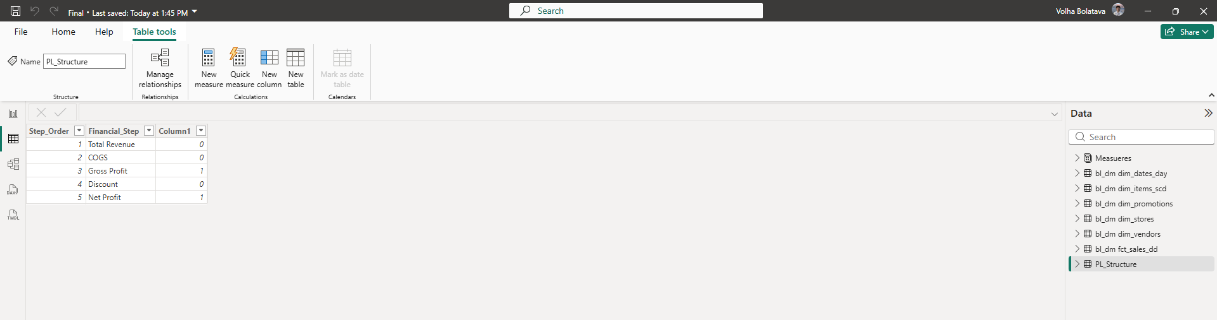
To populate this layout with real values, a master formatting DAX measure was bound to the chart's Y-Axis.This measure intercepts the row context of the custom table and injects the corresponding independent measure, while dynamically flipping the mathematical sign (positive/negative) for expenses: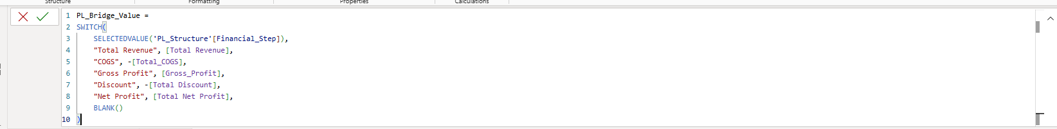
Result:
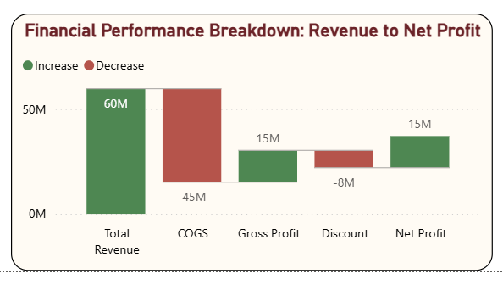
6. Net Profit by Price Segment (Donut Chart)
A donut chart breaking down corporate profitability across consumer budget tiers. It determines whether the business relies on low-margin volume items or if profitability is sustained by the premium category, directly driving future assortment and pricing strategies. Uses a calculated attribute column in the product master table to group sales dynamically:
7.Total COGS and Total Revenue by Year and Month (Area Chart) Overlays cumulative COGS and Total Revenue over time allowing users to visually track the margin gap between revenue and cost of goods. A widening gap signals improving profitability; a narrowing gap signals cost pressure. Outliers and SKUs are grouped dynamically using an architectural calculated column in the product master table that buckets sales into operational text labels: Budget (<$12), Moderate, and Premium (>$35). Measures used: Total_COGS, Total Revenue.
To maximize decision-making speed and efficiency for the executive user, the following UX/UI features were integrated into this page:
- Unified Header & Navigation Bar: Embedded high-contrast button parameters at the top (Sales Performance overview, Product Profitability, Geographical & Vendor Performance) allowing users to switch contexts seamlessly without native Power BI tab clutter.
- Dynamic Time Slicers: Integrated standalone Month and Year dropdown slicers with clear default ("All") parameters to let managers easily drill down into specific historical execution windows.
- Reset Action: Added a dedicated "Reset Filters" action icon (curved arrow) at the top-right corner, allowing users to clear all custom slice selections with a single click and instantly return to the corporate executive summary view.
- Clean Visual Architecture & Palette: Applied a cohesive, professional color scheme (deep corporate wine-red accents with contrasting soft blues and earth tones) matching the AlcoVerse corporate identity while maintaining an optimal data-to-ink ratio for screen presentations.
- Dynamic Visual Titling: A static chart title can mislead executive users when they change filter contexts (e.g., slicing by Year or Month). If a manager filters the report to a single year, a title like "Monthly Trend (All Years)" becomes incorrect and creates cognitive friction. Dynamic titling ensures that the layout adapts instantly, providing clear text confirmation of the active data scope. Instead of hardcoding text in the visual's title property, a dedicated string-returning DAX measure was developed. This measure evaluates the active filter context using ISFILTERED or SELECTEDVALUE functions and builds a human-readable title dynamically:
- Tooltip: Total Revenue by Date Type (Custom Tooltip Page) A custom tooltip page was built and attached to the Monthly Trend combo chart. When a user hovers over any month bar, a pop-up tooltip appears showing: A donut chart splitting Total Revenue between Weekday and Weekend and two KPI mini-cards: Weekend Revenue and Weekend Avg Check. This tooltip directly answers the Business Question about weekend purchasing patterns without requiring a separate page or drill-through. Special calculated column Day Type was created.
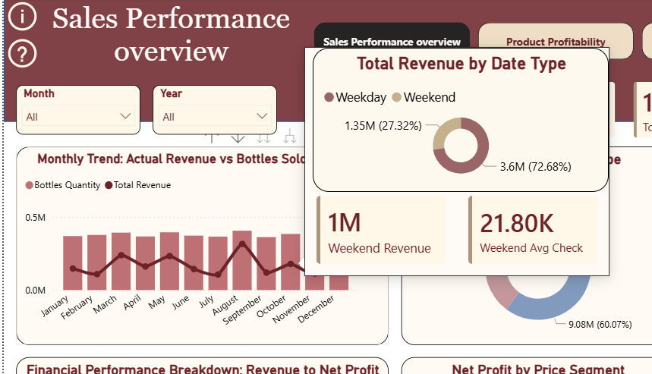
The tooltip page is hidden from the report navigation and surfaces only on hover, keeping the main canvas clean.
- User Guidance Annotations (Instructional Overlays) To improve first-time user orientation, four annotated arrow callouts were added directly onto the report canvas in Power BI using text boxes and shape arrows:
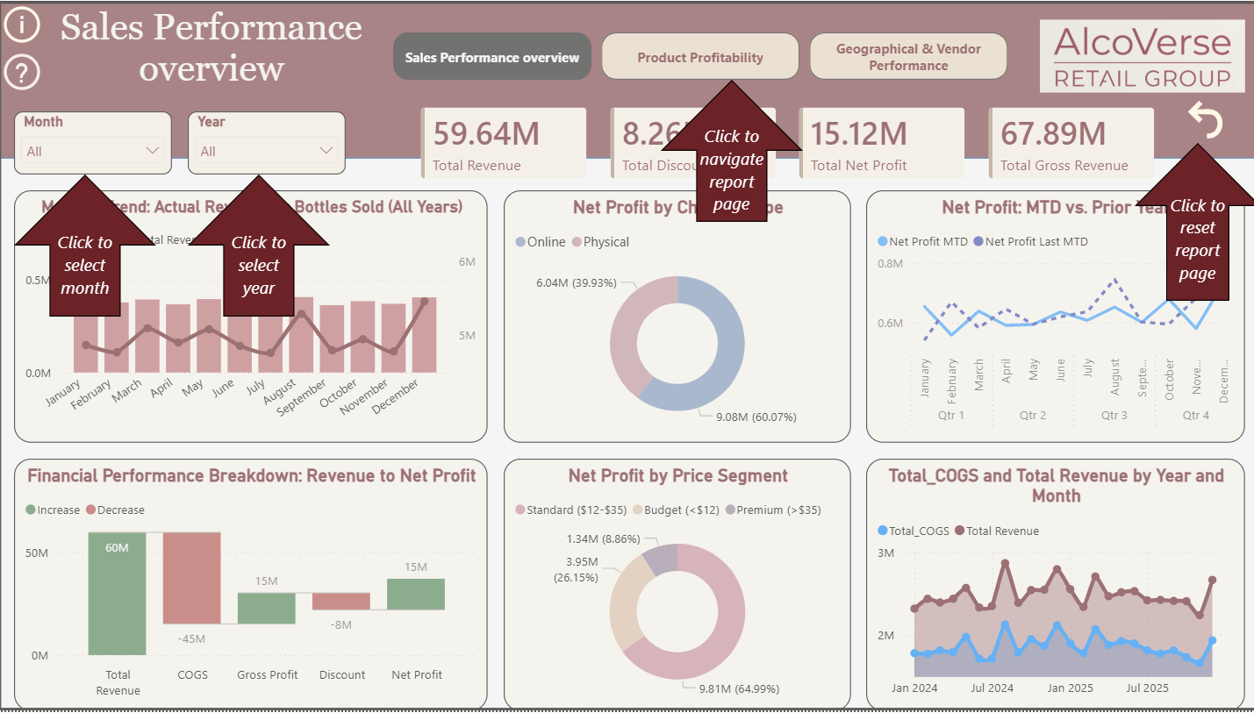
- AI-Powered Self-Service Analytics: Q&A Integration The button in the top-left corner of the report triggers Power BI's built-in Q&A natural language engine, giving any user the ability to query the data model conversationally without needing to navigate between pages or understand the underlying data structure:
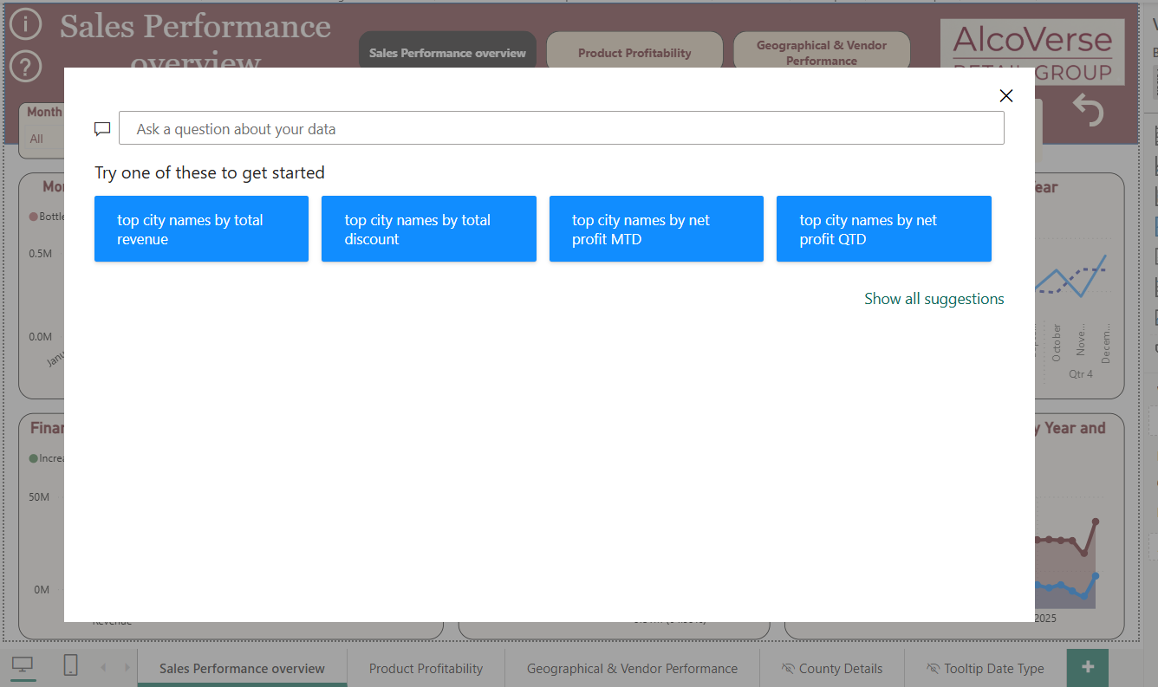
Page 2 - Product Profitability
Page shifts the analytical focus from macro corporate KPIs to granular inventory execution. It resolves the critical business problem of margin cannibalization by tracking product categories, specific items, bottle sizes, and promotional campaigns against actual profitability, ensuring marketing markdowns drive true financial lift rather than eroding bottom-line value.
- KPI Cards (Top Row) The same four headline KPIs from Page 1 (Total Revenue, Total Discount, Total Net Profit, Total Gross Revenue) are carried across all pages to maintain a consistent financial baseline regardless of which page the user is viewing. They remain responsive to the Month and Year slicers.
- Toggle Buttons: Product Category / Top Products Two bookmark-linked buttons in the top-left allow the user to switch the left-side bar chart between two views — an aggregated category-level view and a top individual products view — without navigating away from the page. This was implemented using Power BI Bookmarks + Button Actions, with two versions of the visual hidden/shown on toggle. No additional measures were required.
- Net Profit by Promotional Campaign (Horizontal Bar Chart) Ranks the top 5 promotional campaigns by the Net Profit they generated. This directly resolves the Business Problem of being unable to measure true sales lift per campaign. The visual uses Net Profit filtered through promo_id from dim_promotions.
- Net Profit by Bottle Size (Horizontal Bar Chart) Analyzes pricing-tier and packaging efficiency. It uncovers whether consumer purchasing behavior favors wholesale volume sizes (Large Format) versus individual consumption scales (Standard or Small Format), steering procurement and logistics strategies. Uses an architectural calculated column Bottle Size Group in the product master table to bucket varying milliliter sizes into operational text labels.
To optimize navigating through thousands of inventory items, advanced UI/UX controls were seamlessly embedded:
- Dynamic Metric Toggle Slicers (Product Category vs. Top Products): Implemented using native Field Parameters and bookmark actions (the pills above the category chart). This allows users to switch the entire perspective of the horizontal charts instantly without cluttering the canvas with separate visuals.
- Contextual Navigation Header Alignment: The page retains the unified top header, but the Product Profitability button is highlighted in a dark state, giving immediate visual confirmation of the current working workspace.
- Filter Retention: The Month and Year dropdown slicers carry historical selections across pages via synchronized filter mechanisms, while the executive summary card banner (59.64M Total Revenue, etc.) remains locked at the top to provide a constant corporate baseline anchor for the user.
- Reset Action: Added a dedicated "Reset Filters" action icon (curved arrow) at the top-right corner, allowing users to clear all custom slice selections with a single click and instantly return to the corporate executive summary view.
Report Page 3: Geographical & Vendor Performance (with County Drill-Through)
It resolves the business problem of suboptimal spatial performance by pinpointing exactly where revenue is generated (Geographical insights) and linking it directly to root-cause supply chain partners (Vendor execution). It eliminates guesswork by allowing users to instantly navigate from macro-geography directly into granular regional performance metrics using an advanced Drill-Through mechanism.
- Interactive Geographic Distribution Map (Azure / Map Visual) Identifies regional performance strongholds and market gaps. Instead of scanning endless rows of spreadsheets, it provides an instantaneous visual map of where physical sales points are driving business expansion or lagging. Utilizes the native mapping engine with geographic coordinates tied to store positions. Bubble boundaries and highlights react dynamically to the global filter state.
- Sales Volume by County (Treemap Visual) Provides a fast relative scale comparison of volume concentration across operational regions. Configured with County as the Group dimension and explicit measures tracking total volume or revenue driving the rectangular space bounds.
- Root-Cause Branching: Total Net Profit Hierarchical Analysis (Decomposition Tree)
Solves the core business problem of unguided data exploration. It lets executives systematically break down corporate Total Net Profit by chose path — starting broad with vendor_name and instantly expanding into specific high-margin product groups. The visual is anchored to the master measure [Total Net Profit]. The "Explain By" field contains a logical dimension list: vendor_name and item_category_name, allowing AI-driven split indicators to guide user deep-dives:
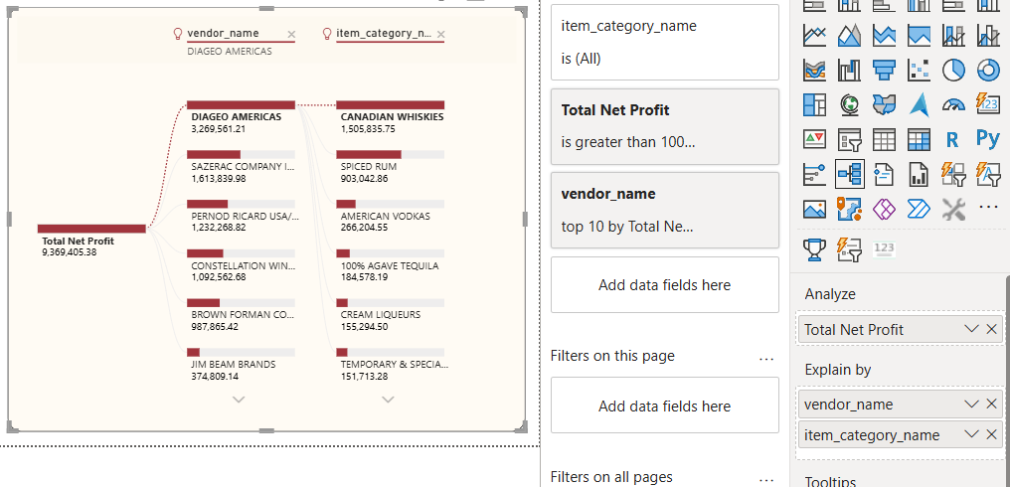
Drill-Through: County Details (Hidden Page)
A Drill-Through was configured on the Treemap, accessible by right-clicking any county tile → Drill through → County Details. This navigates the user to a dedicated hidden sub-page (not visible in the main navigation) that scopes all visuals to the selected county. The County Details page contains:
- Dynamic Title KPI Card — displays the selected county name (First county_name) as a page header, so the user always knows which county they are analyzing
- Monthly Trend: Actual Revenue vs Bottles Sold — the same combo chart from Page 1, now filtered to the drilled-through county only, showing that county's seasonal revenue and volume pattern across all months
- Net Profit by Product (Bar Chart) — top 10 SKUs by Net Profit within that county (example: Linn county — Titos Handmade Vodka leads at $46K)
- Vendor Table: Net Profit — ranked list of all vendors operating in that county with their individual Net Profit contribution
The drill-through page uses a back navigation button to return the user to the Geographical & Vendor Performance page, preserving the filter context. All visuals on this page are powered by the existing measures - no additional DAX was required; the drill-through filter context from county_name automatically scopes every visual.
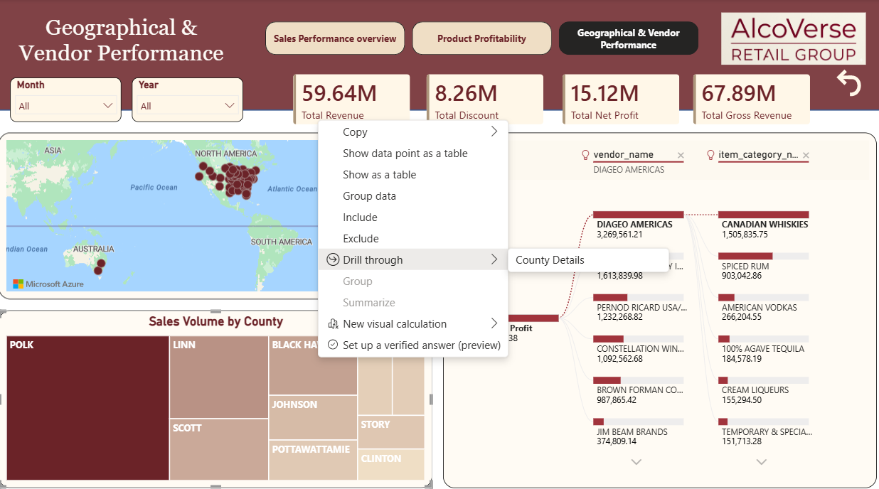
Static row Level Security was implemented to the report based on the type of the channel( Offline and Online).It eliminates data noise by ensuring channel users see only the metrics they are accountable for, also it safeguards highly sensitive financial data, such as channel-specific Net Profit margins and exclusive promotional structures.
Defined strict security roles within Power BI using DAX filter expressions applied directly to the Channel Dimension table (e.g., [Channel_Type] = "Online"). Users are mapped to these roles in the Power BI Service, automatically restricting the dataset rows based on their corporate login: 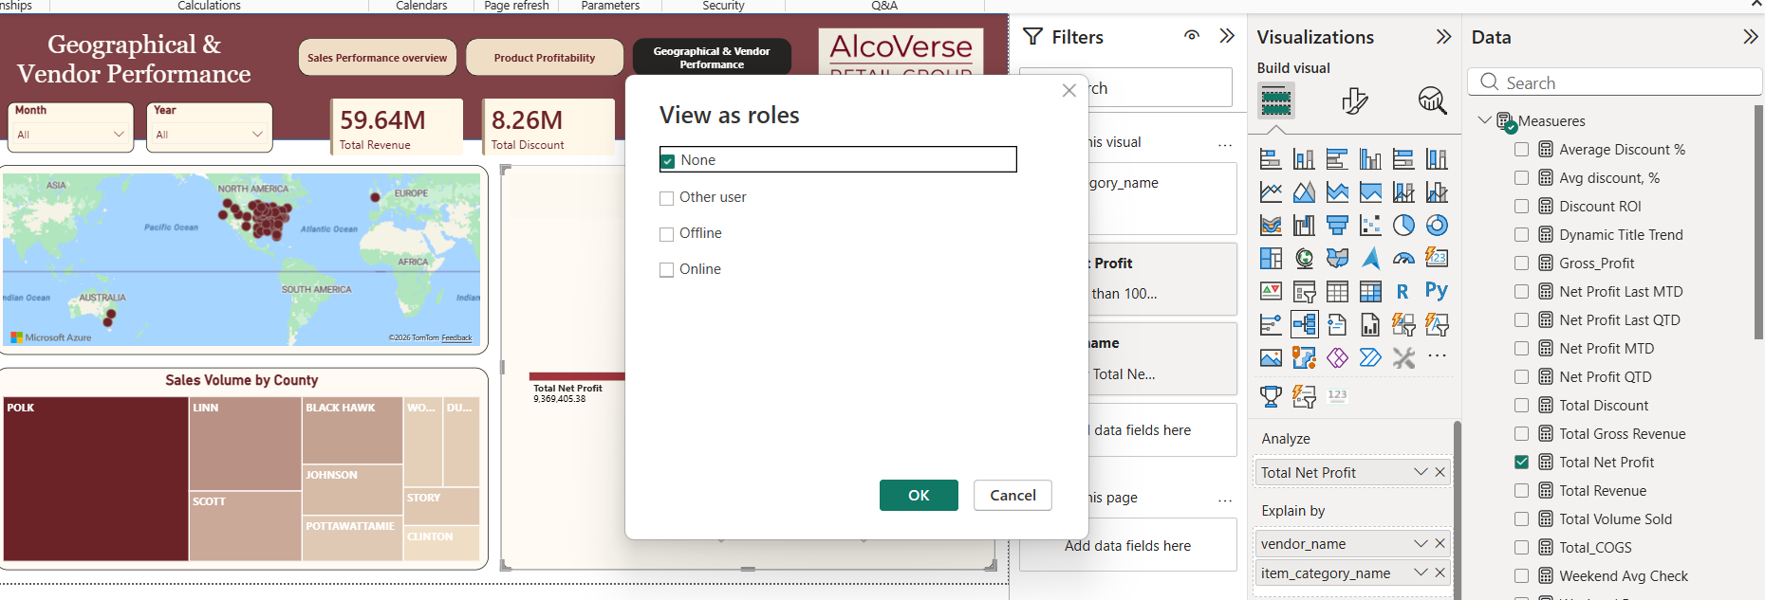
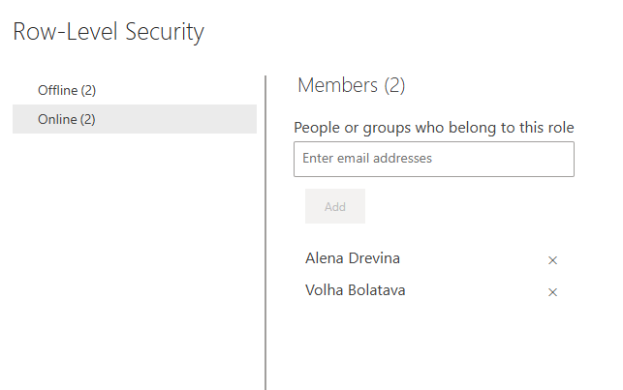
To improve report usability and ensure a more user-friendly experience, the selected values for key slicers have been synchronized across all pages.
Benefits: Users no longer need to re-select the same filter criteria when navigating between different tabs. The selected context is now seamlessly preserved across the entire report, significantly reducing repetitive actions and streamlining the data exploration process.
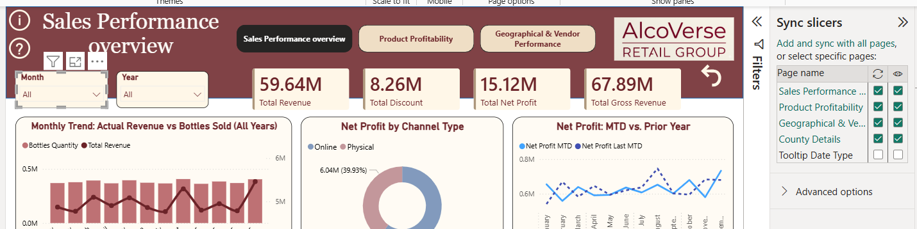
The report was successfully published to Power BI Service Portal:
